

**A WEB APPLICATION ON**

**HR PORTAL**

***of***

**Information Technology**

**Dr. Mahalingam College of Engineering and Technology**

**Pollachi - 642003**

**An Autonomous Institution**

**Affiliated to Anna University, Chennai - 600 025**

**OCTOBER 2019**

**MINI PROJECT REPORT**

**Submitted by**

**R.RAJANA(17BIT054)**

**E.GOKULA PRIYA(17BIT056)**

**A.K.NEERAJ KUMAR(17BIT076)**

**Dr. Mahalingam College of Engineering and Technology**

**Pollachi - 642003**

**An Autonomous Institution**

**Affiliated to Anna University, Chennai - 600 025**

BONAFIDE CERTIFICATE

Certified that this mini project report, “HR PORTAL”

is the bonafide work of

**R.RAJANA(17BIT054)**

**E.GOKULA PRIYA(17BIT056)**

**A.K.NEERAJ KUMAR(17BIT076)**

who carried out the project work under my supervision. The project is carried out over and above the curriculum requirement

**Signature**

Dr.S.Ramakrishnan

HEAD OF THE DEPARTMENT

Information Technology

Dr. Mahalingam College of Engineering

and Technology, NPT-MCET Campus

Pollachi – 642003 India

**Signature**

Mr.Krishnaraj

SUPERVISOR

Assistant Professor/IT

Dr. Mahalingam College of Engineering

and Technology, NPT-MCET Campus

Pollachi – 642003 India

**TABLE OF CONTENTS**

**Title**  **PAGE NO**

1. Abstract 03
2. List of Abbreviations 03
3. List of Figures 03
4. List of Tables 03

1.INTRODUCTION

1.1 Existing System 04

1.2 Disadvantages of Existing 04

1.3 Proposed System 04

1.4 Software Requirement Specification 04

1.5 Objective of Project

2. DESIGN

2.1 Introduction 05

2.2 DFD / ER / UML diagram 06

3. IMPLEMENTATION & RESULTS

3.1 Introduction 07

3.2 Explanation of Key functions07

3.3 Method of Implementation 07

4. CONCLUSION & FUTURE WORK:

4.1 Project Conclusion 07

4.2 Future enhancement 07

References.

APPENDIX A: Screen Shots

APPENDIX B: Sample Code

**ABSTRACT:**

HR portal is a standalone application used to collect the academic information from the user (students). The portal is mainly developed for getting academic information from the student and send the details to the evaluation committee ie, HR for checking the eligiibility of implementing the carrier plans in the organization.

**LIST OF ABBREVIATION**

* WWW-World Wide Web
* html- Hyper Text markup language
* CSS- cascading style sheet

**LIST OF FIGURES**

List of domains are given in the home page.

**LIST OF TABLES**

Guide details is been given in the document.

1. **INTRODUCTION:**

HR portal is a standalone application used to collect the academic details from the user (student). The portal was developed by HTML,CSS and PHP MySQL as the front end & back end. The portal is mainly developed for getting the academic details from the student and send the details to the evaluation committee (HR) for checking the feasibility of implementing of students in the organization. The step by step status of the detail process is known to the user , if the details is approved or rejected by the evaluation committee that information will be send to the user. Finally report will be generated for the each level with all the details like date, internship details, industrial visit details, project details , team member’s details and status of the application.

* 1. **Objective of Project**

The main purpose of the website is to help the students to submit their academic details which will be evaluated by main authority (HR) in the company so that the process for intern , industrial visit can be implemented easily.

* 1. **Existing System**

There is no existing system that provides this portal.

**1.3 Disadvantages of Existing system**  
The disadvantage is that there is currently a desktop application which is slow.

**1.4Proposed System:**

The proposed system will provide the same features of desktop application as a webpage with additional functionalities.

**1.5Software Requirement Specification**

* **Front end**

Html,CSS, JavaScript,Bootstrap,WAMP server (local connectivity).

* **Back end**

PHP MySQL.

1. **DESIGN:**
   1. **Introduction**

The design of the system is been done in a way such that the users and admin both of them can access the website in a easy and reliable manner. There won’t be any difficulty in understanding the view as all modules will be displayed in a single webpage. The tools for the view areHtml, CSS, JavaScript, Bootstrap.

* 1. **DFD / ER / UML diagram**

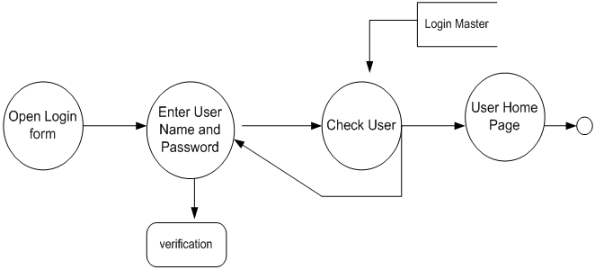

**Diagram 1: HR Portal DFD**

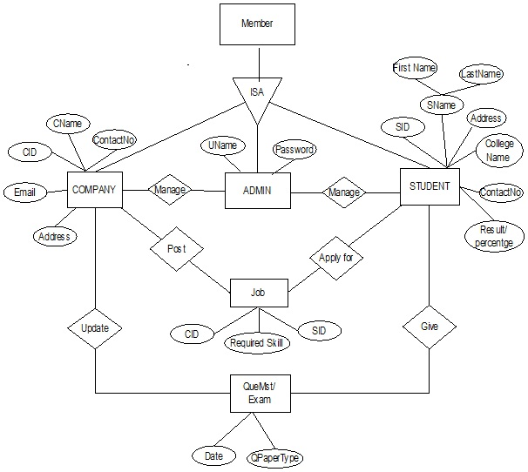

**Diagram 2: HR Portal ER**

**3. IMPLEMENTATION & RESULTS:**

**3.1 Introduction**

The implementation of “HR Portal” has been done by using Html, CSS, JavaScript, Bootstrap.

**3.2 Explanation of Key functions**

It mainly serves the student who are interested in presenting their ideas for their projects,internship offers.

**3.3 Method of Implementation**

The HR Portal website has been done by using Html, CSS, JavaScript, Bootstrap.

**4. CONCLUSION & FUTURE WORK:**

**4.1 Project Conclusion**

Thus, our project will be very helpful to the students for enhancing their academic carrier .

**4.2 Future enhancement**

In future it can be further developed by implementing additional options like adding extra validation, smart onlinechecking, etc.

**APPENDIX A: Screen Shots**

### 

Figure 1:Home Page for Client

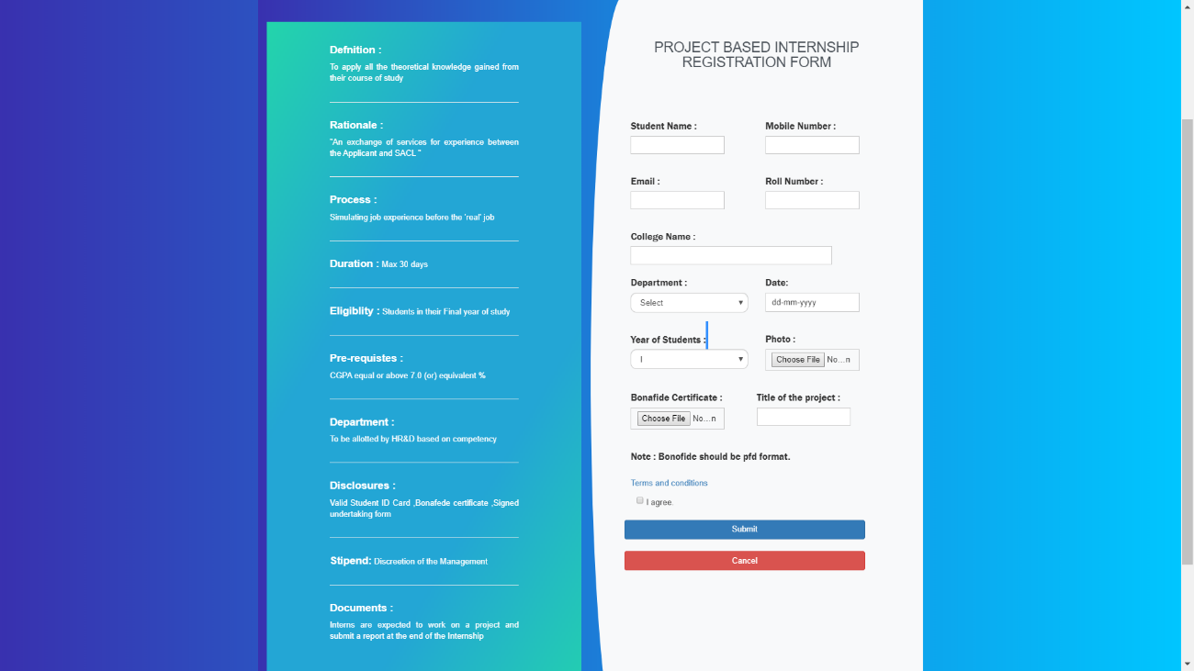

Figure 2:Registration Form Page

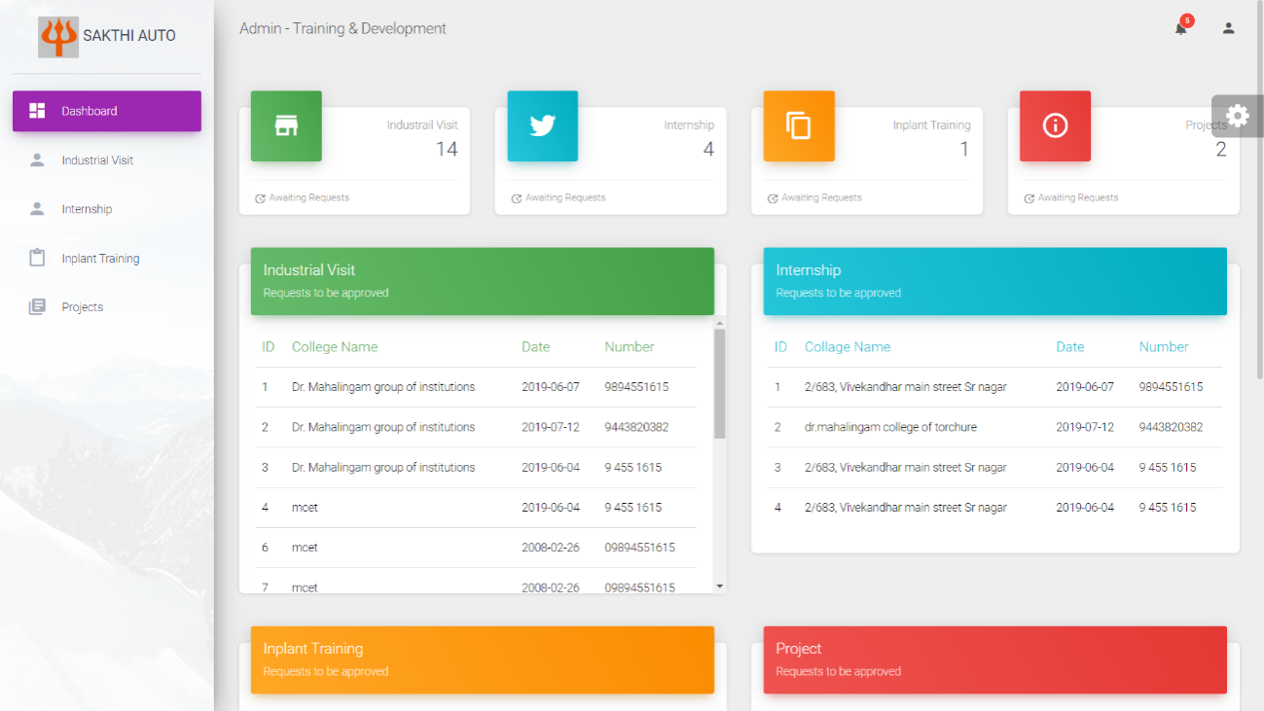

Figure 3: Admin Page

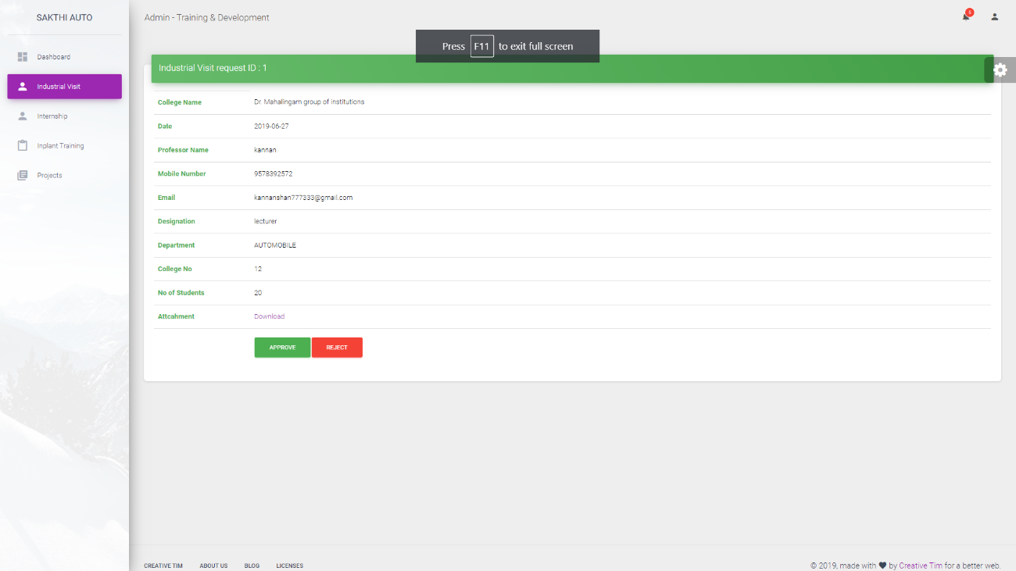

Figure 4: Admin Conformation page

**APPENDIX B: Sample Code**

<!DOCTYPE html>

<html lang="en">

<head>

<title>sakthi</title>

<meta charset="utf-8">

<meta name="viewport" content="width=device-width, initial-scale=1">

<link rel="stylesheet" href="https://maxcdn.bootstrapcdn.com/bootstrap/4.3.1/css/bootstrap.min.css">

<link rel="stylesheet" type="text/css" href="style.css">

<link rel="stylesheet" href="https://cdnjs.cloudflare.com/ajax/libs/font-awesome/4.7.0/css/font-awesome.min.css">

<link rel="stylesheet" href="https://www.w3schools.com/w3css/4/w3.css">

<script src="https://ajax.googleapis.com/ajax/libs/jquery/3.4.0/jquery.min.js"></script>

<script src="https://cdnjs.cloudflare.com/ajax/libs/popper.js/1.14.7/umd/popper.min.js"></script>

<script src="https://maxcdn.bootstrapcdn.com/bootstrap/4.3.1/js/bootstrap.min.js"></script>

<link rel="stylesheet" href="https://maxcdn.bootstrapcdn.com/bootstrap/3.4.0/css/bootstrap.min.css">

<script src="https://maxcdn.bootstrapcdn.com/bootstrap/3.4.0/js/bootstrap.min.js"></script>

</head>

<body style="background: -webkit-linear-gradient(left, #3931af, #00c6ff);">

<div class="row" style="background-color: #0F194E;height: ; " >

<div class="col-sm-8 col-md-8 col-lg-4">

<h3 class="header" style="text-align: left;padding-left: 15px;font-family: georgia;font-size: 20px;">

<img style="float: left;margin-top: -25px;margin-right: 10px" src="sakthi.jpg" height="85">

<div style="margin-left: 30px;"><span style="">Sakthi Auto Component Limited</span></div></h3>

</div>

<div class="col-sm-8 col-md-8 col-lg-8" style="background-color: #f5f5f5f5;">

<h2 class="header" style="font-family: georgia;font-size: 20px;color:black;">Academic Liasons Portal</h2>

</div>

</div>

<div id="nav-container">

<div class="topnav" style="margin-left: 0px;margin-right: 0px;" id="myTopnav" >

<a href="index.html" class="active" ><i class="glyphicon glyphicon-home"></i> Home</a>

<a href="internship.php" ><i class="glyphicon glyphicon-education"></i> Internship</a>

<a href="inplant.php" ><i class="glyphicon glyphicon-blackboard"></i> Inplant Training</a>

<a href="iv.php" ><i class="glyphicon glyphicon-briefcase"></i> Industrial Visit</a>

<a href="project.php"><i class="glyphicon glyphicon-ruble"></i> Project</a>

<a href="javascript:void(0);" class="icon" onclick="myFunction()" >&#9776;</a>

</div>

</div>

<div class="register">

<div class="content-box" onclick="document.getElementById('iv').style.display='block'" >

<div class="row" id="myBtn">

<div class="col-sm-5 col-md-5 col-lg-5">

<div class="hexagon">

<div class="hexagon-inside">

<div class="hexagon-image">

<img class="img-size img-responsive" src="1.jpg" alt="internship" style="margin-left:20px;" />

</div></di>

</div>

</div>

</div>

<div class="col-sm-6 col-md-6 col-lg-6">

<p class="text-justify text-cent">

<strong>Project based Internship</strong><br> To apply all the theoretical knowledge gained from their course of study

<span style="font-family: monospace;"></span>

</p><hr>

<button class="btn btn-success"><a href="internship.php"> cick here to view details</a></buttonclass>

</div>

</div>

</div>

</body>

<footer>

<script src="home.js"></script>

<div class="footer" style="padding-left: 20px;">

<h3 style=" text-align: center;">Sakthi Auto Component Limited</h3>

<div class="row">

<div class="footer-section col-sm-12 col-md-6 col-lg-6 " style="text-align: center;">

<h4>Head Office</h4>

<address>180, Race Course Road, Coimbatore - 641 018, India.<br />

Phone :+91-422-2221551, 4322222<br />

Fax : +91-422-4322488.<br />

Website :

<a href="http://www.sakthiauto.com">http://www.sakthiauto.com </a></address>

</div>

<div class="footer-section form col-sm-12 col-md-6 col-lg-6" style="text-align: center;">

<h4>Factory</h4>

<address>Mukasipallagoundampalayam, Pin : 638 056.<br />

Uthukuli T.K., Tirupur Dist.<br />

Ph : 04294 - 227700 /

Fax : 04294 - 242268.<br />

E - Mail : info@sakthiauto.com</address>

</div>

</div>

<div style="text-align: center;">

<small>&copy;Copyrights by SACL 2019.</small>

</div>

<script src="home.js"></script>

</footer>

</html>

**Admin page:**

<!DOCTYPE html>

<?php

include'src.php';

$query=mysqli_query($con,"select * from ivform where status='na'");

$rc = mysqli_num_rows($query);

$i=0;

while($row=mysqli_fetch_array($query)){

$cname[$i]=$row["cname"];

$id[$i]=$row["id"];

$date[$i]=$row["Date"];

$mnum[$i]=$row["mnum"];

$i++;

}

$query1=mysqli_query($con,"select * from pbiform where status='na'");

$rc1 = mysqli_num_rows($query1);

$a=0;

while($row=mysqli_fetch_array($query1)){

$clgname[$a]=$row["clgname"];

$id[$a]=$row["id"];

$date[$a]=$row["date"];

$mnum[$a]=$row["mnum"];

$a++;

}

$query2=mysqli_query($con,"select * from inplantform where status='na'");

$rc2 = mysqli_num_rows($query2);

$a=0;

while($row=mysqli_fetch_array($query2)){

$clgname[$a]=$row["clgname"];

$id[$a]=$row["id"];

$date[$a]=$row["date"];

$mnum[$a]=$row["mnum"];

$a++;

}

$query3=mysqli_query($con,"select * from projectform where status='na'");

$rc3 = mysqli_num_rows($query3);

$a=0;

while($row=mysqli_fetch_array($query3)){

$clgname[$a]=$row["clgname"];

$id[$a]=$row["id"];

$date[$a]=$row["date"];

$mnum[$a]=$row["mnum"];

$a++;

}

?>

<html lang="en">

<head>

<meta charset="utf-8" />

<link rel="apple-touch-icon" sizes="76x76" href="../assets/img/apple-icon.png">

<link rel="icon" type="image/png" href="../assets/img/favicon.png">

<meta http-equiv="X-UA-Compatible" content="IE=edge,chrome=1" />

<title>

Admin

</title>

<meta content='width=device-width, initial-scale=1.0, maximum-scale=1.0, user-scalable=0, shrink-to-fit=no' name='viewport' />

<!-- Fonts and icons -->

<link rel="stylesheet" type="text/css" href="https://fonts.googleapis.com/css?family=Roboto:300,400,500,700|Roboto+Slab:400,700|Material+Icons" />

<link rel="stylesheet" href="https://maxcdn.bootstrapcdn.com/font-awesome/latest/css/font-awesome.min.css">

<!-- CSS Files -->

<link href="../assets/css/material-dashboard.css?v=2.1.1" rel="stylesheet" />

<!-- CSS Just for demo purpose, don't include it in your project -->

<link href="../assets/demo/demo.css" rel="stylesheet" />

</head>

<body class="">

<div class="wrapper ">

<div class="sidebar" data-color="purple" data-background-color="white" data-image="../assets/img/sidebar-1.jpg">

<!--

Tip 1: You can change the color of the sidebar using: data-color="purple | azure | green | orange | danger"

Tip 2: you can also add an image using data-image tag

-->

<div class="logo">

<a href="http://www.creative-tim.com" class="simple-text logo-normal"><img src="vel.jpg" width="50" height="50">

Sakthi Auto

</a>

</div>

<div class="sidebar-wrapper">

<ul class="nav">

<li class="nav-item active ">

<a class="nav-link" href="">

<i class="material-icons">dashboard</i>

<p>Dashboard</p>

</a>

</li>

<li class="nav-item ">

<a class="nav-link" href="ivdata.php">

<i class="material-icons">person</i>

<p>Industrial Visit</p>

</a>

</li>

<li class="nav-item ">

<a class="nav-link" href="pbidata.php">

<i class="material-icons">person</i>

<p>Internship</p>

</a>

</li>

<li class="nav-item ">

<a class="nav-link" href="inplantdata.php">

<i class="material-icons">content_paste</i>

<p>Inplant Training</p>

</a>

</li>

<li class="nav-item ">

<a class="nav-link" href="projectdata.php">

<i class="material-icons">library_books</i>

<p>Projects</p>

</a>

</li>

<!--<li class="nav-item ">

<a class="nav-link" href="./icons.html">

<i class="material-icons">bubble_chart</i>

<p>Icons</p>

</a>

</li>

<li class="nav-item ">

<a class="nav-link" href="./map.html">

<i class="material-icons">location_ons</i>

<p>Maps</p>

</a>

</li>

<li class="nav-item ">

<a class="nav-link" href="./notifications.html">

<i class="material-icons">notifications</i>

<p>Notifications</p>

</a>

</li>

<li class="nav-item ">

<a class="nav-link" href="./rtl.html">

<i class="material-icons">language</i>

<p>RTL Support</p>

</a>

</li>-->

</ul>

</div>

</div>

<div class="main-panel">

<!-- Navbar -->

<nav class="navbar navbar-expand-lg navbar-transparent navbar-absolute fixed-top ">

<div class="container-fluid">

<div class="navbar-wrapper">

<a class="navbar-brand" href="#pablo">Admin - Training & Development</a>

</div>

<button class="navbar-toggler" type="button" data-toggle="collapse" aria-controls="navigation-index" aria-expanded="false" aria-label="Toggle navigation">

<span class="sr-only">Toggle navigation</span>

<span class="navbar-toggler-icon icon-bar"></span>

<span class="navbar-toggler-icon icon-bar"></span>

<span class="navbar-toggler-icon icon-bar"></span>

</button>

<div class="collapse navbar-collapse justify-content-end">

<ul class="navbar-nav">

<li class="nav-item dropdown">

<a class="nav-link" href="http://example.com" id="navbarDropdownMenuLink" data-toggle="dropdown" aria-haspopup="true" aria-expanded="false">

<i class="material-icons">notifications</i>

<span class="notification">5</span>

<p class="d-lg-none d-md-block">

Some Actions

</p>

</a>

<div class="dropdown-menu dropdown-menu-right" aria-labelledby="navbarDropdownMenuLink">

<a class="dropdown-item" href="#">Mike John responded to your email</a>

<a class="dropdown-item" href="#">You have 5 new tasks</a>

<a class="dropdown-item" href="#">You're now friend with Andrew</a>

<a class="dropdown-item" href="#">Another Notification</a>

<a class="dropdown-item" href="#">Another One</a>

</div>

</li>

<li class="nav-item dropdown">

<a class="nav-link" href="#pablo" id="navbarDropdownProfile" data-toggle="dropdown" aria-haspopup="true" aria-expanded="false">

<i class="material-icons">person</i>

<p class="d-lg-none d-md-block">

Account

</p>

</a>

<div class="dropdown-menu dropdown-menu-right" aria-labelledby="navbarDropdownProfile">

<a class="dropdown-item" href="#">Profile</a>

<a class="dropdown-item" href="#">Settings</a>

<div class="dropdown-divider"></div>

<a class="dropdown-item" href="#">Log out</a>

</div>

</li>

</ul>

</div>

</div>

</nav>

<!-- End Navbar -->

<div class="content">

<div class="container-fluid">

<div class="row">

<div class="col-lg-3 col-md-6 col-sm-6">

<div class="card card-stats">

<div class="card-header card-header-success card-header-icon">

<div class="card-icon">

<i class="material-icons">store</i>

</div>

<p class="card-category">Industrail Visit</p>

<h3 class="card-title"><?php echo $rc; ?></h3>

</div>

<div class="card-footer">

<div class="stats">

<i class="material-icons">update</i> Awaiting Requests

</div>

</div>

</div>

</div>

<div class="col-lg-3 col-md-6 col-sm-6">

<div class="card card-stats">

<div class="card-header card-header-info card-header-icon">

<div class="card-icon">

<i class="fa fa-twitter"></i>

</div>

<p class="card-category">Internship</p>

<h3 class="card-title"><?php echo $rc1; ?></h3>

</div>

<div class="card-footer">

<div class="stats">

<i class="material-icons">update</i> Awaiting Requests

</div>

</div>

</div>

</div>

<div class="col-lg-3 col-md-6 col-sm-6">

<div class="card card-stats">

<div class="card-header card-header-warning card-header-icon">

<div class="card-icon">

<i class="material-icons">content_copy</i>

</div>

<p class="card-category">Inplant Training</p>

<h3 class="card-title"><?php echo $rc2; ?>

</h3>

</div>

<div class="card-footer">

<div class="stats">

<i class="material-icons">update</i> Awaiting Requests

</div>

</div>

</div>

</div>

<div class="col-lg-3 col-md-6 col-sm-6">

<div class="card card-stats">

<div class="card-header card-header-danger card-header-icon">

<div class="card-icon">

<i class="material-icons">info_outline</i>

</div>

<p class="card-category">Projects</p>

<h3 class="card-title"><?php echo $rc3; ?></h3>

</div>

<div class="card-footer">

<div class="stats">

<i class="material-icons">update</i> Awaiting Requests

</div>

</div>

</div>

</div>

</div>

<div class="row">

<div class="col-lg-6 col-md-12" >

<div class="card" style="height:400px;" >

<div class="card-header card-header-success">

<h4 class="card-title">Industrial Visit</h4>

<p class="card-category">Requests to be approved</p>

</div>

<div class="card-body table-responsive">

<table class="table table-hover">

<thead class="text-success">

<th>ID</th>

<th>College Name</th>

<th>Date</th>

<th>Number</th>

</thead>

<tbody>

<?php for($j=0;$j<$rc;$j++){ ?>

<tr>

<td><a style="color:black;" href='ivc.php?idd=<?php echo $id[$j]; ?>'><?php echo $id[$j]; ?></a></td>

<td><a style="color:black;" href='ivc.php?idd=<?php echo $id[$j]; ?>'><?php echo $cname[$j]; ?></a></td>

<td><a style="color:black;" href='ivc.php?idd=<?php echo $id[$j]; ?>'><?php echo $date[$j]; ?></a></td>

<td><a style="color:black;" href='ivc.php?idd=<?php echo $id[$j]; ?>'><?php echo $mnum[$j]; ?></a></td>

</tr>

<?php } ?>

</tbody>

</table>

</div>

</div>

</div>

<div class="col-lg-6 col-md-12">

<div class="card">

<div class="card-header card-header-info">

<h4 class="card-title">Internship</h4>

<p class="card-category">Requests to be approved </p>

</div>

<div class="card-body table-responsive">

<table class="table table-hover">

<thead class="text-info">

<th>ID</th>

<th>Collage Name</th>

<th>Date</th>

<th>Number</th>

</thead>

<tbody>

<?php for($j=0;$j<$rc1;$j++){ ?>

<tr>

<td><a style="color:black;" href='pbic.php?idd=<?php echo $id[$j]; ?>'><?php echo $id[$j]; ?></a></td>

<td><a style="color:black;" href='pbic.php?idd=<?php echo $id[$j]; ?>'><?php echo $clgname[$j]; ?></a></td>

<td><a style="color:black;" href='pbic.php?idd=<?php echo $id[$j]; ?>'><?php echo $date[$j]; ?></a></td>

<td><a style="color:black;" href='pbic.php?idd=<?php echo $id[$j]; ?>'><?php echo $mnum[$j]; ?></a></td>

</tr>

<?php } ?>

</tbody>

</table>

</div>

</div>

</div>

</div>

<div class="row">

<div class="col-lg-6 col-md-12">

<div class="card">

<div class="card-header card-header-warning">

<h4 class="card-title">Inplant Training</h4>

<p class="card-category">Requests to be approved</p>

</div>

<div class="card-body table-responsive">

<table class="table table-hover">

<thead class="text-warning">

<th>ID</th>

<th>Collage Name</th>

<th>Date</th>

<th>Number</th>

</thead>

<tbody>

<?php for($j=0;$j<$rc2;$j++){ ?>

<tr>

<td><a style="color:black;" href='inplantc.php?idd=<?php echo $id[$j]; ?>'><?php echo $id[$j]; ?></a></td>

<td><a style="color:black;" href='inplantc.php?idd=<?php echo $id[$j]; ?>'><?php echo $clgname[$j]; ?></a></td>

<td><a style="color:black;" href='innplantc.php?idd=<?php echo $id[$j]; ?>'><?php echo $date[$j]; ?></a></td>

<td><a style="color:black;" href='inplantc.php?idd=<?php echo $id[$j]; ?>'><?php echo $mnum[$j]; ?></a></td>

</tr>

<?php } ?>

</tbody>

</table>

</div>

</div>

</div>

<div class="col-lg-6 col-md-12">

<div class="card">

<div class="card-header card-header-danger">

<h4 class="card-title">Project</h4>

<p class="card-category">Requests to be approved</p>

</div>

<div class="card-body table-responsive">

<table class="table table-hover">

<thead class="text-danger">

<th>ID</th>

<th>Name</th>

<th>Date</th>

<th>Number</th>

</thead>

<tbody>

<?php for($j=0;$j<$rc2;$j++){ ?>

<tr>

<td><a style="color:black;" href='projectc.php?idd=<?php echo $id[$j]; ?>'><?php echo $id[$j]; ?></a></td>

<td><a style="color:black;" href='projectc.php?idd=<?php echo $id[$j]; ?>'><?php echo $clgname[$j]; ?></a></td>

<td><a style="color:black;" href='projectc.php?idd=<?php echo $id[$j]; ?>'><?php echo $date[$j]; ?></a></td>

<td><a style="color:black;" href='projectc.php?idd=<?php echo $id[$j]; ?>'><?php echo $mnum[$j]; ?></a></td>

</tr>

<?php } ?>

</tbody>

</table>

</div>

</div>

</div>

</div>

</div>

</div>

<footer class="footer">

<div class="container-fluid">

<nav class="float-left">

<ul>

<li>

<a href="https://www.creative-tim.com">

Creative Tim

</a>

</li>

<li>

<a href="https://creative-tim.com/presentation">

About Us

</a>

</li>

<li>

<a href="http://blog.creative-tim.com">

Blog

</a>

</li>

<li>

<a href="https://www.creative-tim.com/license">

Licenses

</a>

</li>

</ul>

</nav>

<!--<div class="copyright float-right">

&copy;

<script>

document.write(new Date().getFullYear())

</script>, made with <i class="material-icons">favorite</i> by

<a href="https://www.creative-tim.com" target="_blank">Creative Tim</a> for a better web.

</div>-->

</div>

</footer>

</div>

</div>

<div class="fixed-plugin">

<div class="dropdown show-dropdown">

<a href="#" data-toggle="dropdown">

<i class="fa fa-cog fa-2x"></i>

</a>

<ul class="dropdown-menu">

<li class="header-title"> Sidebar Filters</li>

<li class="adjustments-line">

<a href="javascript:void(0)" class="switch-trigger active-color">

<div class="badge-colors ml-auto mr-auto">

<span class="badge filter badge-purple" data-color="purple"></span>

<span class="badge filter badge-azure" data-color="azure"></span>

<span class="badge filter badge-green" data-color="green"></span>

<span class="badge filter badge-warning" data-color="orange"></span>

<span class="badge filter badge-danger" data-color="danger"></span>

<span class="badge filter badge-rose active" data-color="rose"></span>

</div>

<div class="clearfix"></div>

</a>

</li>

<li class="header-title">Images</li>

<script src="../assets/js/core/popper.min.js"></script>

<script src="../assets/js/core/bootstrap-material-design.min.js"></script>

<script src="../assets/js/plugins/perfect-scrollbar.jquery.min.js"></script>

<!-- Plugin for the momentJs -->

<script src="../assets/js/plugins/moment.min.js"></script>

<!-- Plugin for Sweet Alert -->

<script src="../assets/js/plugins/sweetalert2.js"></script>

<!-- Forms Validations Plugin -->

<script src="../assets/js/plugins/jquery.validate.min.js"></script>

<!-- Plugin for the Wizard, full documentation here: https://github.com/VinceG/twitter-bootstrap-wizard -->

<script src="../assets/js/plugins/jquery.bootstrap-wizard.js"></script>

<!-- Plugin for Select, full documentation here: http://silviomoreto.github.io/bootstrap-select -->

<script src="../assets/js/plugins/bootstrap-selectpicker.js"></script>

<!-- Plugin for the DateTimePicker, full documentation here: https://eonasdan.github.io/bootstrap-datetimepicker/ -->

<script src="../assets/js/plugins/bootstrap-datetimepicker.min.js"></script>

<!-- DataTables.net Plugin, full documentation here: https://datatables.net/ -->

<script src="../assets/js/plugins/jquery.dataTables.min.js"></script>

<!-- Plugin for Tags, full documentation here: https://github.com/bootstrap-tagsinput/bootstrap-tagsinputs -->

<script src="../assets/js/plugins/bootstrap-tagsinput.js"></script>

<!-- Plugin for Fileupload, full documentation here: http://www.jasny.net/bootstrap/javascript/#fileinput -->

<script src="../assets/js/plugins/jasny-bootstrap.min.js"></script>

<!-- Full Calendar Plugin, full documentation here: https://github.com/fullcalendar/fullcalendar -->

<script src="../assets/js/plugins/fullcalendar.min.js"></script>

<!-- Vector Map plugin, full documentation here: http://jvectormap.com/documentation/ -->

<script src="../assets/js/plugins/jquery-jvectormap.js"></script>

<!-- Plugin for the Sliders, full documentation here: http://refreshless.com/nouislider/ -->

<script src="../assets/js/plugins/nouislider.min.js"></script>

<!-- Include a polyfill for ES6 Promises (optional) for IE11, UC Browser and Android browser support SweetAlert -->

<script src="https://cdnjs.cloudflare.com/ajax/libs/core-js/2.4.1/core.js"></script>

<!-- Library for adding dinamically elements -->

<script src="../assets/js/plugins/arrive.min.js"></script>

<!-- Google Maps Plugin -->

<script src="https://maps.googleapis.com/maps/api/js?key=YOUR_KEY_HERE"></script>

<!-- Chartist JS -->

<script src="../assets/js/plugins/chartist.min.js"></script>

<!-- Notifications Plugin -->

<script src="../assets/js/plugins/bootstrap-notify.js"></script>

<!-- Control Center for Material Dashboard: parallax effects, scripts for the example pages etc -->

<script src="../assets/js/material-dashboard.js?v=2.1.1" type="text/javascript"></script>

<!-- Material Dashboard DEMO methods, don't include it in your project! -->

<script src="../assets/demo/demo.js"></script>

<script>

$(document).ready(function() {

$().ready(function() {

$sidebar = $('.sidebar');

$sidebar_img_container = $sidebar.find('.sidebar-background');

$full_page = $('.full-page');

$sidebar_responsive = $('body > .navbar-collapse');

window_width = $(window).width();

fixed_plugin_open = $('.sidebar .sidebar-wrapper .nav li.active a p').html();

if (window_width > 767 && fixed_plugin_open == 'Dashboard') {

if ($('.fixed-plugin .dropdown').hasClass('show-dropdown')) {

$('.fixed-plugin .dropdown').addClass('open');

}}

$('.fixed-plugin a').click(function(event) {

// Alex if we click on switch, stop propagation of the event, so the dropdown will not be hide, otherwise we set the section active

if ($(this).hasClass('switch-trigger')) {

if (event.stopPropagation) {

event.stopPropagation();

} else if (window.event) {

window.event.cancelBubble = true;

}}});

$('.fixed-plugin .active-color span').click(function() {

$full_page_background = $('.full-page-background');

$(this).siblings().removeClass('active');

$(this).addClass('active');

var new_color = $(this).data('color');

if ($sidebar.length != 0) {

$sidebar.attr('data-color', new_color);

}

if ($full_page.length != 0) {

$full_page.attr('filter-color', new_color);

}

if ($sidebar_responsive.length != 0) {

$sidebar_responsive.attr('data-color', new_color);

}});

$('.fixed-plugin .background-color .badge').click(function() {

$(this).siblings().removeClass('active');

$(this).addClass('active');

var new_color = $(this).data('background-color');

if ($sidebar.length != 0) {

$sidebar.attr('data-background-color', new_color);

}});

$('.fixed-plugin .img-holder').click(function() {

$full_page_background = $('.full-page-background');

$(this).parent('li').siblings().removeClass('active');

$(this).parent('li').addClass('active');

var new_image = $(this).find("img").attr('src');

if ($sidebar_img_container.length != 0 && $('.switch-sidebar-image input:checked').length != 0) {

$sidebar_img_container.fadeOut('fast', function() {

$sidebar_img_container.css('background-image', 'url("' + new_image + '")');

$sidebar_img_container.fadeIn('fast');

});}

if ($full_page_background.length != 0 && $('.switch-sidebar-image input:checked').length != 0) {

var new_image_full_page = $('.fixed-plugin li.active .img-holder').find('img').data('src');

$full_page_background.fadeOut('fast', function() {

$full_page_background.css('background-image', 'url("' + new_image_full_page + '")');

$full_page_background.fadeIn('fast');

});

}

if ($('.switch-sidebar-image input:checked').length == 0) {

var new_image = $('.fixed-plugin li.active .img-holder').find("img").attr('src');

var new_image_full_page = $('.fixed-plugin li.active .img-holder').find('img').data('src');

$sidebar_img_container.css('background-image', 'url("' + new_image + '")');

$full_page_background.css('background-image', 'url("' + new_image_full_page + '")');

}

if ($sidebar_responsive.length != 0) {

$sidebar_responsive.css('background-image', 'url("' + new_image + '")');

} });

$('.switch-sidebar-image input').change(function() {

$full_page_background = $('.full-page-background');

$input = $(this);

if ($input.is(':checked')) {

if ($sidebar_img_container.length != 0) {

$sidebar_img_container.fadeIn('fast');

$sidebar.attr('data-image', '#');

}

if ($full_page_background.length != 0) {

$full_page_background.fadeIn('fast');

$full_page.attr('data-image', '#');

}

background_image = true;

} else {

if ($sidebar_img_container.length != 0) {

$sidebar.removeAttr('data-image');

$sidebar_img_container.fadeOut('fast');

}

if ($full_page_background.length != 0) {

$full_page.removeAttr('data-image', '#');

$full_page_background.fadeOut('fast');

}

background_image = false;

}

});

$('.switch-sidebar-mini input').change(function() {

$body = $('body');

$input = $(this);

if (md.misc.sidebar_mini_active == true) {

$('body').removeClass('sidebar-mini');

md.misc.sidebar_mini_active = false;

$('.sidebar .sidebar-wrapper, .main-panel').perfectScrollbar();

} else {

$('.sidebar .sidebar-wrapper, .main-panel').perfectScrollbar('destroy');

setTimeout(function() {

$('body').addClass('sidebar-mini');

md.misc.sidebar_mini_active = true;

}, 300);

}

// we simulate the window Resize so the charts will get updated in realtime.

var simulateWindowResize = setInterval(function() {

window.dispatchEvent(new Event('resize'));

}, 180);

// we stop the simulation of Window Resize after the animations are completed

setTimeout(function() {

clearInterval(simulateWindowResize);

}, 1000);

});

});

});

</script>

<script>

$(document).ready(function() {

// Javascript method's body can be found in assets/js/demos.js

md.initDashboardPageCharts();

});

</script>

</body>

</html>